**Домашнее задание 1**

**Вариант 62**

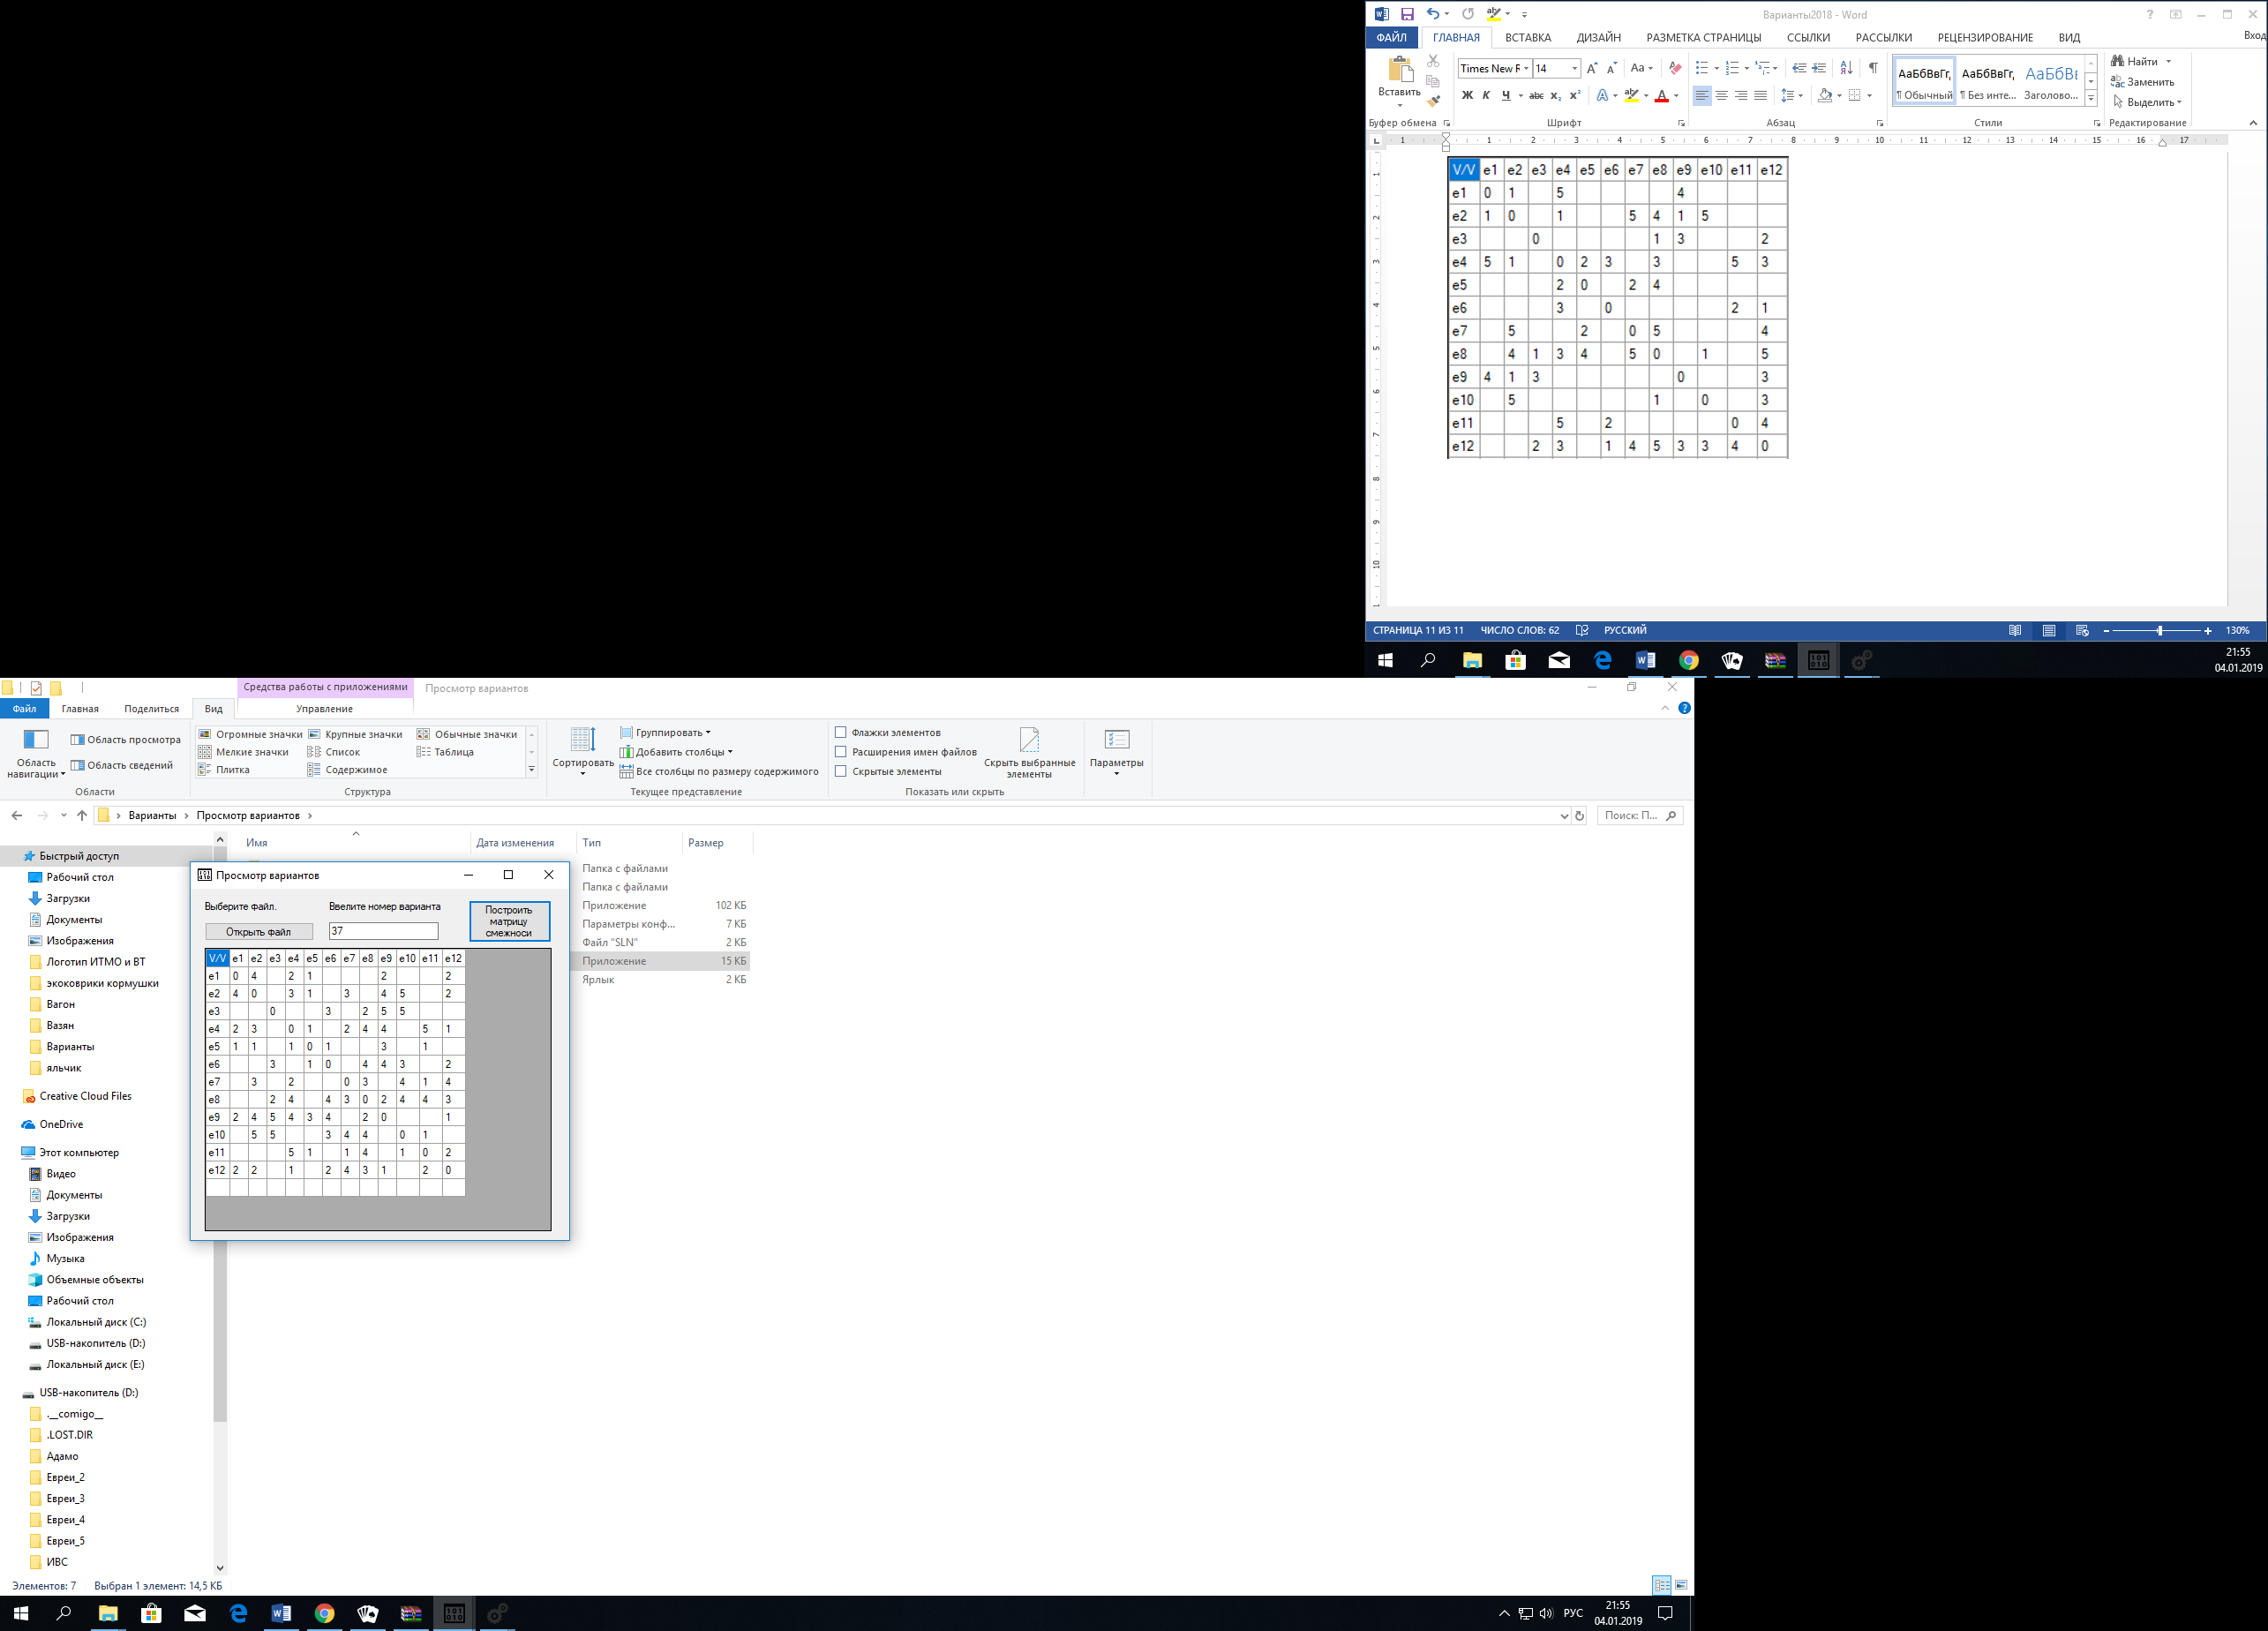

|  |  |  |  |  |  |  |  |  |  |  |  |  |
| --- | --- | --- | --- | --- | --- | --- | --- | --- | --- | --- | --- | --- |
| V/V | **E1** | **E2** | **E3** | **E4** | **E5** | **E6** | **E7** | **E8** | **E9** | **E10** | **E11** | **E12** |
| **E1** | 0 | 4 |  | 2 | 1 |  |  |  | 2 |  |  | 2 |
| **E2** | 4 | 0 |  | 3 | 1 |  | 3 |  | 4 | 5 |  | 2 |
| **E3** |  |  | 0 |  |  | 3 |  | 2 | 5 | 5 |  |  |
| **E4** | 2 | 3 |  | 0 | 1 |  | 2 | 4 | 4 |  | 5 | 1 |
| **E5** | 1 | 1 |  | 1 | 0 | 1 |  |  | 3 |  | 1 |  |
| **E6** |  |  | 3 |  | 1 | 0 |  | 4 | 4 | 3 |  | 2 |
| **E7** |  | 3 |  | 2 |  |  | 0 | 3 |  | 4 | 1 | 4 |
| **E8** |  |  | 2 | 4 |  | 4 | 3 | 0 | 2 | 4 | 4 | 3 |
| **E9** | 2 | 4 | 5 | 4 | 3 | 4 |  | 2 | 0 |  |  | 1 |
| **E10** |  | 5 | 5 |  |  | 3 | 4 | 4 |  | 0 | 1 |  |
| **E11** |  |  |  | 5 | 1 |  | 1 | 4 |  | 1 | 0 | 2 |
| **E12** | 2 | 2 |  | 1 |  | 2 | 4 | 3 | 1 |  | 2 | 0 |

1. Положим, что j = 1:
2. Посчитаем кол-во ненулевых элементов ri в матрице R:

|  |  |  |  |  |  |  |  |  |  |  |  |  |  |
| --- | --- | --- | --- | --- | --- | --- | --- | --- | --- | --- | --- | --- | --- |
| V/V | **E1** | **E2** | **E3** | **E4** | **E5** | **E6** | **E7** | **E8** | **E9** | **E10** | **E11** | **E12** | **ri** |
| **E1** | 0 | 1 |  | 1 | 1 |  |  |  | 1 |  |  | 1 | 5 |
| **E2** | 1 | 0 |  | 1 | 1 |  | 1 |  | 1 | 1 |  | 1 | 7 |
| **E3** |  |  | 0 |  |  | 1 |  | 1 | 1 | 1 |  |  | 4 |
| **E4** | 1 | 1 |  | 0 | 1 |  | 1 | 1 | 1 |  | 1 | 1 | 8 |
| **E5** | 1 | 1 |  | 1 | 0 | 1 |  |  | 1 |  | 1 |  | 6 |
| **E6** |  |  | 1 |  | 1 | 0 |  | 1 | 1 | 1 |  | 1 | 6 |
| **E7** |  | 1 |  | 1 |  |  | 0 | 1 |  | 1 | 1 | 1 | 6 |
| **E8** |  |  | 1 | 1 |  | 1 | 1 | 0 | 1 | 1 | 1 | 1 | 8 |
| **E9** | 1 | 1 | 1 | 1 | 1 | 1 |  | 1 | 0 |  |  | 1 | 8 |
| **E10** |  | 1 | 1 |  |  | 1 | 1 | 1 |  | 0 | 1 |  | 6 |
| **E11** |  |  |  | 1 | 1 |  | 1 | 1 |  | 1 | 0 | 1 | 6 |
| **E12** | 1 | 1 |  | 1 |  | 1 | 1 | 1 | 1 |  | 1 | 0 | 8 |

1. Упорядочим вершины графа в порядке убывания ri:

**e4, e8, e9, e12, e2, e5, e6, e7, e10, e11, e1, e3**

1. Красим в цвет 1 вершины **e4, e3**. Удаляем строчки с этими вершинами
2. Пусть j = j + 1 = 2

|  |  |  |  |  |  |  |  |  |  |  |  |  |  |
| --- | --- | --- | --- | --- | --- | --- | --- | --- | --- | --- | --- | --- | --- |
| V/V | **E1** | **E2** | **E3** | **E4** | **E5** | **E6** | **E7** | **E8** | **E9** | **E10** | **E11** | **E12** | **ri** |
| **E1** | 0 | 1 |  | 1 | 1 |  |  |  | 1 |  |  | 1 | 5 |
| **E2** | 1 | 0 |  | 1 | 1 |  | 1 |  | 1 | 1 |  | 1 | 7 |
| **E5** | 1 | 1 |  | 1 | 0 | 1 |  |  | 1 |  | 1 |  | 6 |
| **E6** |  |  | 1 |  | 1 | 0 |  | 1 | 1 | 1 |  | 1 | 6 |
| **E7** |  | 1 |  | 1 |  |  | 0 | 1 |  | 1 | 1 | 1 | 6 |
| **E8** |  |  | 1 | 1 |  | 1 | 1 | 0 | 1 | 1 | 1 | 1 | 8 |
| **E9** | 1 | 1 | 1 | 1 | 1 | 1 |  | 1 | 0 |  |  | 1 | 8 |
| **E10** |  | 1 | 1 |  |  | 1 | 1 | 1 |  | 0 | 1 |  | 6 |
| **E11** |  |  |  | 1 | 1 |  | 1 | 1 |  | 1 | 0 | 1 | 6 |
| **E12** | 1 | 1 |  | 1 |  | 1 | 1 | 1 | 1 |  | 1 | 0 | 8 |

1. Упорядочим вершины графа в порядке убывания ri:

**e8, e9, e12, e2, e5, e6, e7, e10, e11, e1**

1. Красим в цвет 2 вершины **e8, e1**. Удаляем строчки с этими вершинами
2. Пусть j = j + 1 = 3

|  |  |  |  |  |  |  |  |  |  |  |  |  |  |
| --- | --- | --- | --- | --- | --- | --- | --- | --- | --- | --- | --- | --- | --- |
| V/V | **E1** | **E2** | **E3** | **E4** | **E5** | **E6** | **E7** | **E8** | **E9** | **E10** | **E11** | **E12** | **ri** |
| **E2** | 1 | 0 |  | 1 | 1 |  | 1 |  | 1 | 1 |  | 1 | 7 |
| **E5** | 1 | 1 |  | 1 | 0 | 1 |  |  | 1 |  | 1 |  | 6 |
| **E6** |  |  | 1 |  | 1 | 0 |  | 1 | 1 | 1 |  | 1 | 6 |
| **E7** |  | 1 |  | 1 |  |  | 0 | 1 |  | 1 | 1 | 1 | 6 |
| **E9** | 1 | 1 | 1 | 1 | 1 | 1 |  | 1 | 0 |  |  | 1 | 8 |
| **E10** |  | 1 | 1 |  |  | 1 | 1 | 1 |  | 0 | 1 |  | 6 |
| **E11** |  |  |  | 1 | 1 |  | 1 | 1 |  | 1 | 0 | 1 | 6 |
| **E12** | 1 | 1 |  | 1 |  | 1 | 1 | 1 | 1 |  | 1 | 0 | 8 |

1. Упорядочим вершины графа в порядке убывания ri:

**e9, e12, e2, e5, e6, e7, e10, e11**

1. Красим в цвет 3 вершины **e9, e7**. Удаляем строчки с этими вершинами
2. Пусть j = j + 1 = 4

|  |  |  |  |  |  |  |  |  |  |  |  |  |  |
| --- | --- | --- | --- | --- | --- | --- | --- | --- | --- | --- | --- | --- | --- |
| V/V | **E1** | **E2** | **E3** | **E4** | **E5** | **E6** | **E7** | **E8** | **E9** | **E10** | **E11** | **E12** | **ri** |
| **E2** | 1 | 0 |  | 1 | 1 |  | 1 |  | 1 | 1 |  | 1 | 7 |
| **E5** | 1 | 1 |  | 1 | 0 | 1 |  |  | 1 |  | 1 |  | 6 |
| **E6** |  |  | 1 |  | 1 | 0 |  | 1 | 1 | 1 |  | 1 | 6 |
| **E10** |  | 1 | 1 |  |  | 1 | 1 | 1 |  | 0 | 1 |  | 6 |
| **E11** |  |  |  | 1 | 1 |  | 1 | 1 |  | 1 | 0 | 1 | 6 |
| **E12** | 1 | 1 |  | 1 |  | 1 | 1 | 1 | 1 |  | 1 | 0 | 8 |

1. Упорядочим вершины графа в порядке убывания ri:

**e12, e2, e5, e6, e10, e11**

1. Красим в цвет 4 вершины **e12, e5, e10**. Удаляем строчки с этими вершинами
2. Пусть j = j + 1 = 5

|  |  |  |  |  |  |  |  |  |  |  |  |  |  |
| --- | --- | --- | --- | --- | --- | --- | --- | --- | --- | --- | --- | --- | --- |
| V/V | **E1** | **E2** | **E3** | **E4** | **E5** | **E6** | **E7** | **E8** | **E9** | **E10** | **E11** | **E12** | **ri** |
| **E2** | 1 | 0 |  | 1 | 1 |  | 1 |  | 1 | 1 |  | 1 | 7 |
| **E6** |  |  | 1 |  | 1 | 0 |  | 1 | 1 | 1 |  | 1 | 6 |
| **E11** |  |  |  | 1 | 1 |  | 1 | 1 |  | 1 | 0 | 1 | 6 |

1. Упорядочим вершины графа в порядке убывания ri:

**e2, e6, e11**

1. Красим в цвет 5 вершины **e2, e6, e11**. Удаляем строчки с этими вершинами
2. Все вершины окрашены. Хроматическое число равно 5.